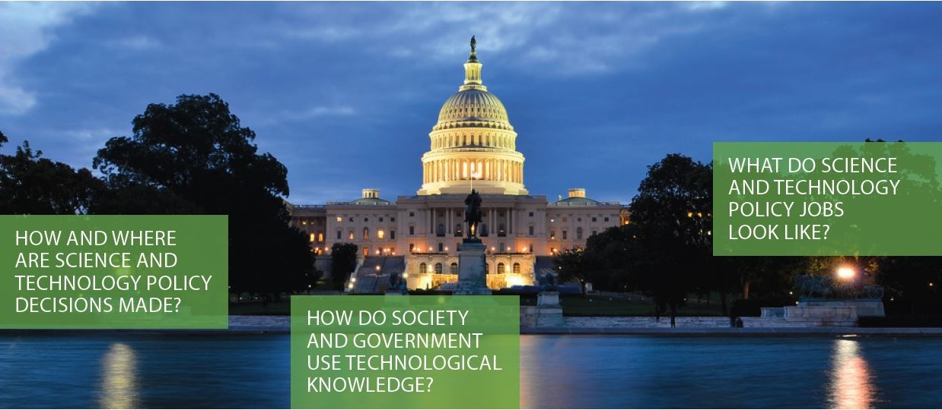
Science Outside the Lab
Nanotechnology and Policy
Faculty Program: May 29 – 31, 2024 (tentative)
Grad Student/Post doc Program: June 2 – 8, 2024 (tentative)

Science Outside the Lab brings a small cohort of scientists and engineers to Washington, D.C. to explore the relationships among science, innovation, and policy. The goal is to expose participants to as many different viewpoints as possible and help them understand how people and institutions influence and learn from the sciences.

In 2024 the Nanotechnology Collaborative Infrastructure Southwest (NCI-SW) and the NNCI Coordinating Office will sponsor two programs: one for faculty and one for PhD students and Post Docs. During the workshops, participants will investigate the context of science and technology decision-making with a focus on the US Federal Government. Participants will meet and interact with congressional staffers, funding agency officers, regulators, journalists, museum curators, and others to learn how and why nanotechnology and other emerging technologies are funded, regulated, shaped, critiqued, and publicized.

Graduate students and faculty affiliated with National Nanotechnology Coordinated Infrastructure universities (https://nnci.net/sites/view-all) are especially encouraged to apply to their respective programs. We are looking for candidates interested in how decisions are made about science and innovation funding, regulation, and policy. Applications should open in January and will be due in February 2024.

For more information see: https://nnci.net/science-outside-lab
or contact Jamey Wetmore Wetmore@asu.edu
